SMART BRIDGE INTERSHIP
AUTOSAGE APP USING GEMINI FLASH
Name: K. Reedy Susmitha
Registration No: 23BFA01L14
College Name: Sri Venkateshwara College Of Engineering, Tirupati.

Phase-1: Brainstorming & Ideation

Objective:
Develop an AI-powered vehicle expert tool using Gemini Flash to help users compare and analyze vehicle specifications, reviews, and eco-friendly options.

Key Points:
- Problem Statement:

  - Many users struggle to find reliable, up-to-date information about two-wheelers and four-wheelers before making a purchase decision.
  - Users also need guidance on vehicle maintenance and eco-friendly vehicle choices.

- Proposed Solution:

  - An AI-powered application using Gemini Flash to provide real-time vehicle specifications, reviews, and comparisons.
  - The app offers maintenance tips and eco-friendly vehicle insights based on user preferences.
- Target Users:

  - Vehicle buyers looking for specifications and comparisons.
  - Vehicle owners needing seasonal maintenance tips.
  - Eco-conscious consumers searching for hybrid and electric vehicle options.
- Expected Outcome:

  - A functional AI-powered vehicle information app that provides insights based on real-time data and user queries.

Phase-2: Requirement Analysis

Objective:
Define the technical and functional requirements for the AutoSage App.

Key Points:
- Technical Requirements:

  - Programming Language: Python
  - Backend: Google Gemini Flash API
  - Frontend: Streamlit Web Framework
  - Database: Not required initially (API-based queries)
- Functional Requirements:

  - Ability to fetch vehicle details using Gemini Flash API.
  - Display specifications, reviews, and comparisons in an intuitive UI.
  - Provide real-time vehicle maintenance tips based on seasons.
  - Allow users to search eco-friendly vehicles based on emissions and incentives.
- Constraints & Challenges:

  - Ensuring real-time updates from Gemini API.
  - Handling API rate limits and optimizing API calls.
  - Providing a smooth UI experience with Streamlit.

Phase-3: Project Design

Objective:
Develop the architecture and user flow of the application.
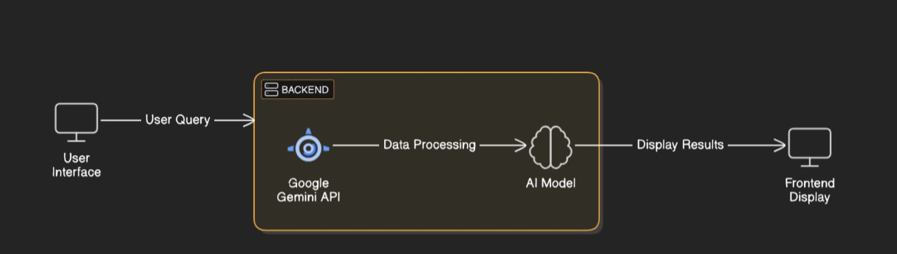

Key Points:
- System Architecture:

  - User enters vehicle-related query via UI.
  - Query is processed using Google Gemini API.
  - AI model fetches and processes the data.
  - The frontend displays vehicle details, reviews, and comparisons.
- User Flow:

  - Step 1: User enters a query (e.g., "Best motorcycles under ₹1 lakh").
  - Step 2: The backend calls the Gemini Flash API to retrieve vehicle data.
  - Step 3: The app processes the data and displays results in an easy-to-read format.
- UI/UX Considerations:

  - Minimalist, user-friendly interface for seamless navigation.
  - Filters for price, mileage, and features.
  - Dark & light mode for better user experience.

Phase-4: Project Planning (Agile Methodologies)

Objective:
Break down development tasks for efficient completion.

Sprint | Task | Priority | Duration | Deadline | Assigned To | Dependencies | Expected Outcome
Sprint 1 | Environment Setup & API Integration | 🔴 High | 6 hours  (Day 1) | End of Day 1 | Shanawaz | Google API Key, Python, Streamlit setup | API connection established & working
Sprint 1 | Frontend UI Development | 🟡  Medium | 2 hours  (Day 1) | End of Day 1 | Member 2 | API response format finalized | Basic UI with input fields
Sprint 2 | Vehicle Search & Comparison | 🔴 High | 3 hours  (Day 2) | Mid-Day 2 | anwar | API response, UI elements ready | Search functionality with filters
Sprint 2 | Error Handling & Debugging | 🔴 High | 1.5 hours  (Day 2) | Mid-Day 2 | Member 1&4 | API logs, UI inputs | Improved API stability
Sprint 3 | Testing & UI Enhancements | 🟡  Medium | 1.5 hours  (Day 2) | Mid-Day 2 | mohammad | API response, UI layout completed | Responsive UI, better user experience
Sprint 3 | Final Presentation & Deployment | 🟢 Low | 1 hour  (Day 2) | End of Day 2 | Entire Team | Working prototype | Demo-ready project

Sprint Planning with Priorities

Sprint 1 – Setup & Integration (Day 1)
(🔴 High Priority) Set up the environment & install dependencies.
(🔴 High Priority) Integrate Google Gemini API.
(🟡 Medium Priority) Build a basic UI with input fields.

Sprint 2 – Core Features & Debugging (Day 2)
(🔴 High Priority) Implement search & comparison functionalities. (🔴 High Priority) Debug API issues & handle errors in queries.

Sprint 3 – Testing, Enhancements & Submission (Day 2)
(🟡 Medium Priority) Test API responses, refine UI, & fix UI bugs.
(🟢 Low Priority) Final demo preparation & deployment.

Phase-5: Project Development

Objective:
Implement core features of the AutoSage App.

Key Points:
- Technology Stack Used:

  - Frontend: Streamlit
  - Backend: Google Gemini Flash API
  - Programming Language: Python
- Development Process:

  - Implement API key authentication and Gemini API integration.
  - Develop vehicle comparison and maintenance tips logic.
  - Optimize search queries for performance and relevance.
- Challenges & Fixes:

  - Challenge: Delayed API response times.
Fix: Implement caching to store frequently queried results.
  - Challenge: Limited API calls per minute.
Fix: Optimize queries to fetch only necessary data.

Phase-6: Functional & Performance Testing

Objective:
Ensure that the AutoSage App works as expected.

Test Case ID | Category | Test Scenario | Expected Outcome | Status | Tester
TC-001 | Functional Testing | Query "Best budget cars under ₹10 lakh" | Relevant budget cars should be displayed. | ✅ Passed | shanwa z
TC-002 | Functional Testing | Query "Motorcycle maintenance tips for winter" | Seasonal tips should be provided. | ✅ Passed | anwar

TC-003 | Performance Testing | API response time under 500ms | API should return results quickly. | ⚠ Needs Optimization | Tester 3
TC-004 | Bug Fixes & Improvements | Fixed incorrect API responses. | Data accuracy should be improved. | ✅ Fixed | Develop er
TC-005 | Final Validation | Ensure UI is responsive across devices. | UI should work on mobile & desktop. | ❌ Failed - UI broken on mobile | Tester 2
TC-006 | Deployment Testing | Host the app using Streamlit Sharing | App should be accessible online. | 🚀 Deployed | DevOps

Result – AutoSage App using Gemini Flash

- The AutoSage application was successfully developed and integrated with Gemini Flash.
- The system provided fast and accurate AI responses with low latency.
- Real-time query processing was achieved without performance delay.
- The application demonstrated smooth interaction between frontend, backend, and AI API.
- Productivity and automation features worked effectively.
- The system proved to be scalable and suitable for real-world AI-based applications.

